1. Project Title: AI-Based Real Estate Valuation System
2. Project Statement and Outcomes:
- Predicting house prices is a complex task influenced by multiple factors, such as location, size, number of rooms, and economic conditions. Due to the dynamic nature of the housing market, traditional methods struggle to estimate prices accurately. This project aims to build a machine-learning model using supervised learning to predict house prices based on historical data.
- By the end of this project, we will have successfully built a machine-learning model capable of predicting house prices based on various property attributes. We will explore and analyze the various Housing Datasets to understand key factors influencing real estate prices. Using ML algorithms, we will train our model on a portion of the dataset and then use it to make predictions on unseen data. The model's performance will be evaluated using appropriate metrics to assess its accuracy and reliability providing valuable insights into housing price estimation and the impact of different property features.

3. Modules to be Implemented:
- Data Collection, Preprocessing, and Data Transformation
- Model Training, Development, and Evaluation
- User Interface & User Interactions
- Testing, Review, and Documentation
4. Week-wise Module Implementation and High-Level Requirements:
Weeks 1-2: Data Collection, Preprocessing, and Data Transformation
- Collect the Housing Dataset or any other suitable dataset.
- Handle missing values, outliers, and inconsistencies.
- Ensure the dataset is balanced and representative of different house price ranges.
- Perform exploratory data analysis (EDA) to understand data distribution and relationships.

Weeks 3-4: Model Training, Development, and Evaluation
- Split the dataset into training and testing sets (e.g., 80-20 split).
- Train a Linear Regression model and compare it with other models like Decision Tree, Random Forest, or XGBoost.
- Evaluate model performance using RMSE, MAE, and R² score.
- Optimize hyperparameters to improve model accuracy.

Week 5-6: User Interface & User Interactions
- Develop a Streamlit web application to allow users to input house details and receive predictions.
- Integrate visualizations such as feature importance, price distribution, and market trends.
Weeks 7-8: Testing, Review, and Documentation
- Conduct thorough testing and validation to ensure reliability.
- Document the entire process, including data collection, preprocessing, model selection, and deployment.
- Prepare a final report summarizing insights from the project.
5. Flow chart:
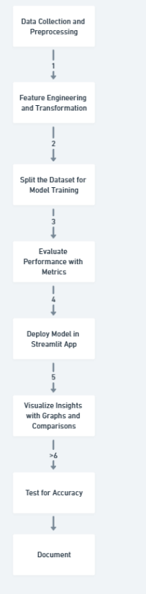

6. Sample Dashboard:

